Why Is There Pain?
Ana el mafrood bal3ab tamrena lel biceps, leeh el forearm tewga3ny aslan? For two reasons:
- Wenta bete3mel curls, enta bet 5aly 2abdet 2edak da5la le gowa shwaya as shown below:
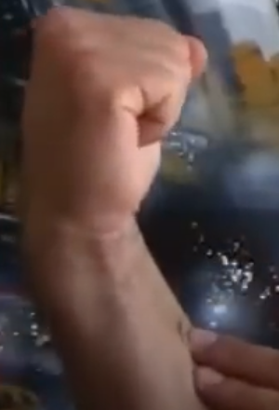
Da actually beyshel goz2 men el pressure 3an el biceps w bey7oto 3ala el forearm. Instead, keep your wrist in a netural position as shown below, y3ny 5aly 2abdet 2edak mashya 3la nafs el 5at ma3 el forearm.
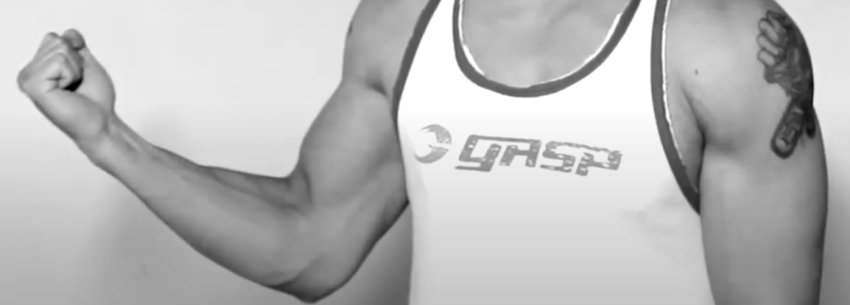
Or even drop your wrist forward (also called “bend your wrist”) as shown below:
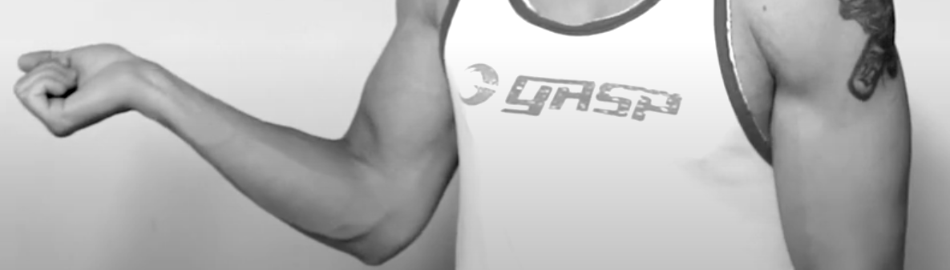
- Lazem teb2a 3aref en fi two positions for your arm lama tefredha:
  - Pronation: da lama tefred 2edak le odam with your palm facing the ground.
  - Supination: da lama tefred 2edak le odam with your palm facing upward.
Anhy position beyeb2a more neutral and convenient for your arm? Pronation! Garab keda pronate 2edak, then lefaha such that you supinate, akeed 7aseet en b2a fih tension 3al forearm. Tab3an we7na bene3mel curls, fa7na beneb2a in the supination position el howa aslan mesh moree7 3la el 2eed. Tyb 3ayzak b2a tegarab te rotate 2edak aktar, y3ny enta delwa2ty 3amel supination and your palm is facing the ceiling, la2 7awel telef 2edak aktar 7ata be este5dam 2edak el tanya. El mawdoo3 sa3b w 7aseet be tension aktar 3al forearm, sa7? El fekra b2a en enta lama betel3ab be wazn at2al men el enta te2dar 3leeh, el beye7sal en enta bet7awel te rotate your arm aktar men el supination position da. Ezay bs ana mb3mlsh keda? Maho enta mesh hat7es en el forearm 3ayza te rotate aktar la2en enta beteb2a shayel el bar, bs internally da el beyeb2a el forearm 3ayez ye3melo 3ashan yesa3dak terfa3 el wazn el te2eel da. Fa ta5ayal en enta awalan in the supination position while you are curling el howa mesh moree7 lel forearm, kaman masek weight 7atet pressure aktar w aktar 3al forearm, W KAMAN el weight da at2al men ma enta te2dar testa7mel fa el forearm bet7awel enaha te rotate aktar causing more and more tension. Watch this video from 1:29 to 1:54.

Solutions
- Bend your wrist forward to lower the tension on the forearm.
- Do not lift too heavy weight! You should be able to control the weight in every single rep.
- Don’t grip the bar too narrow or too wide, your grip should be a shoulder-width grip.
- Use an EZ bar (i.e. don’t use a straight bar) and hold it as shown below. Keda enta 2alelt el supination angle shwaya, badal ma el palm bases lel sa2f, la2 b2a wa5ed zawya shwaya.
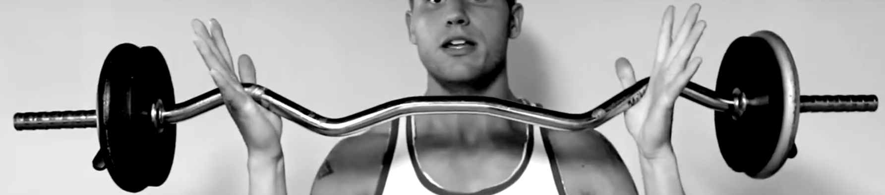

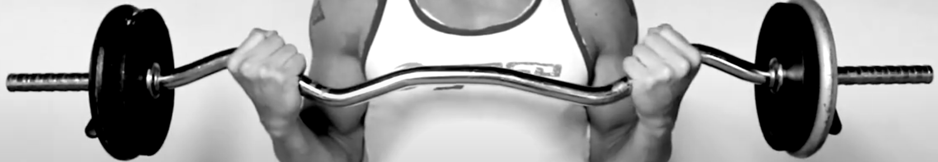

- When you finish your set and put the weight down, don’t immediately pull your hands off the bar, wait a few seconds.
- If you are still feeling pain when using an EZ bar, switch to dumbbells, and again, don’t lift heavier than you can or instead your hand can rotate outward as shown below, which would put pressure on the forearm:
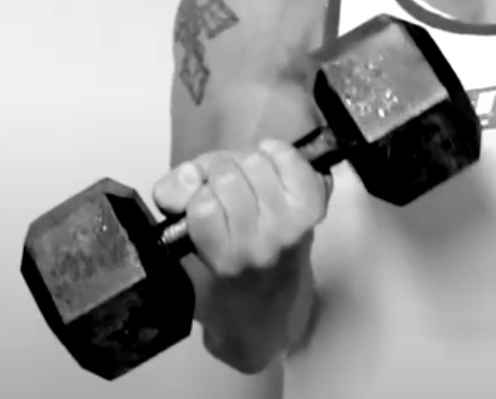
Also, don’t forget to bend your wrist as shown below:
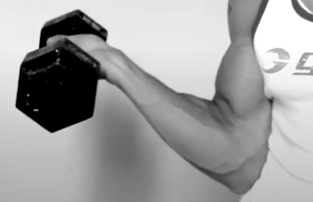
- E3ml exercises lel forearm wel wrist 3ashan yeb2o aqwa, check “Wrist_Exercises” note.

